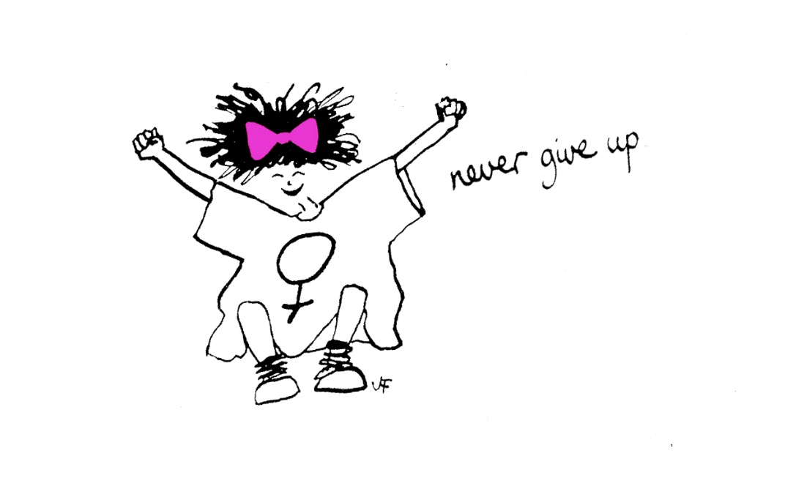

Evaluation of The Freedom Programme – Online
29th October 2020 – 21st January 2021.
Sharon Bryan Consultancy Community Interest Company.
Company Number: 12882606.

Introduction
This evaluation examines the efficacy of The Freedom Programme. Through a quantitative assessment, this evaluation examines the impact and outcomes of the Freedom Programme for participants of the online group programme, which was conducted between the 29^{th of} October 2020 to the 21^{st of} January 2021.

Impact of COVID-19 and subsequent lockdowns.
Since the inception of the COVID-19 pandemic and subsequent national lockdowns, the Freedom Programme has not been able to run in the normal way, which has historically been face to face group sessions. Instead, login details for the Freedom Programme Online are purchased for £12 each and given to the women that have been offered a place on the online group programme, along with instructions on how to access the online programme on the national Freedom Programme website.
Conducting the programme online has its advantages and its disadvantages! The main disadvantage is that the group sessions lack the physical connection that women often feel is important.
“It is harder to connect with the other women when it is online. I think it would have been nice to have been able to give each other a cuddle when one of us became upset, but obviously, we can’t do that online”.
The obvious advantages of the programme being online are that women can attend from anywhere in the country or even the world! It is much more cost effective to run a programme online as there are no fee’s for venue hire or childcare. When a physical programme is run, we also give out copies of ‘Living with the Dominator’ and ‘The Home Study Course’ to each woman. By giving the women access to the online programme, they have access to the same content, but this is also cheaper to purchase than the books. For the women, there is obviously the advantage of not having to travel or leave their homes. However, this can be a disadvantage for women who are still living with the abusive partner or who have children who are not in school, particularly during the pandemic when schools have been closed.

Aims of The Freedom Programme.
The Freedom Programme is a support group designed for women who are or have been experiencing domestic abuse. The Freedom Programme is designed as an intervention to empower women to make positive choices about their lives by providing information and support, within a group setting. It gives women an opportunity and space to develop ways of thinking and behaving to protect themselves and their children from harm.
The aims of The Freedom Programme are:
- To help women understand the beliefs held by abusive men and in doing so, recognise which of these beliefs they have shared.
- To illustrate the effects of domestic abuse on children.
- To assist women to recognise potential future abusers.
- To help women gain self-esteem and the confidence to improve the quality of their lives.
- To introduce women to other women who share similar experiences.
The Freedom Programme comprises 11, 90-minute sessions held weekly and run by a qualified facilitator.
The Freedom Programme was developed in the UK by Pat Craven who works in the area of domestic abuse.

Evaluation Methodology
The information was collated using client questionnaires with qualitative and quantitative questions. For the purposes of evaluation, a section was added in relation to completing the programme online via zoom.

Process
- The client questionnaires were sent out by email after 9 sessions of the programme had been completed.
- Attendees were told there was no obligation to complete the questionnaire.

Response Rate
There were 9 women who completed all 11 sessions. There were a number of women who referred themselves to the programme that either did not attend or could not attend for various reasons. Out of the 9 who completed all 11 sessions, 8 returned their questionnaires. The one woman who did not return their questionnaire, did not do so because she contracted COVID-19 and was unwell during the last 2 sessions, although she still attended.

Main Findings
The analysis was very positive. The main quantitative findings are outlined below.
- 100% of participants said The Freedom Programme had a positive impact on their lives.
- 100% of participants said they found The Freedom Programme very helpful.

Because of their participation in The Freedom Programme
- 100% strongly agreed, that the programme has resulted in a positive change in their lives.
- 100% agreed, of which 75% strongly agreed, they are more hopeful for the future.
- 90% agreed, of which 50% strongly agreed, that they are more assertive. 10% disagreed but felt they were getting there.
- 90% agreed, of which 60% strongly agreed, that they were more confident. 10% disagreed but again felt they were getting there.
- 100% agreed, of which 50% strongly agreed, they no longer blame themselves for their abuser’s behaviour.
- 100% agreed, of which 60% strongly agreed, that they can now make more sense of their abusers’ behaviour.
- 100% agreed, of which 60% strongly agreed, they now feel less along in their experience of domestic abuse,
- 100% agreed, of which 90% strongly agreed, that they now expect to be respected.
- 100% agreed, of which 80% strongly agreed, that they can now recognise and identify abusive behaviour.
- 100% agreed, of which 60% strongly agreed, that they feel they have the ability to respond to abusive behaviour.
- 100% agree, of which 80% strongly agreed, that they could now recognise an unhealthy relationship.
- 100% agreed, of which 80% strongly agreed, that they understood more about the impact of domestic abuse on children.
As well as the quantitative findings, women had the opportunity to explain their reasons for selecting their answers. The main themes that emerged from the qualitative questions were:
- Greater awareness of abusive behaviours.
- Better perspective and understanding that the abuse is not their fault.
- Peer support, “I am not along”, “Finally someone understands!”.
- Realisation that domestic abuse is not just about being hit! More understanding of coercive control and emotional abuse.
- All of the women felt that the programme should be more widely advertised so that more women know about it and can attend.

Detailed Analysis
Overall impact of The Freedom Programme
The overall impact was very positive with 100% of those who completed the questionnaire saying that The Freedom Programme had a positive impact on their lives.
What were the impacts of The Freedom Programme
- “Shown me how to recognise abuse and educated me on it”.
- “Made me notice a lot that I didn’t during the relationship”.
- “You see a lot that you didn’t realise before as abusive”.
- “Good to have someone to talk to who has been through a similar situation”.
- “Better understanding towards life and situations we are in”.
- “The programme has helped me on how I see myself. It has given me back my voice and confidence”.
- “I feel stronger than when I started the programme”.
- “Knowledge is power!”.
- “Recognise abusive behaviours for what they are and helps put things in perspective and hopefully help me make better choices in the future”.
- “Having the weekly meetings and course structure has helped me to keep positive on my decision to end the relationship. The support of Sharon has been so much more than I had expected. Plus hearing others stories helped me to get some clarity on what was abusive and that those behaviours were not those of a healthy relationship”.
Overall rating of the usefulness of the programme by participants
100% of course participants listed the programme as being very helpful.
- “A well-structured programme to aid women in understanding what they have been through”.
- “Educational information not available anywhere else that I can find”.
- “Having the group discussions and being able to talk with Sharon really gave perspective. The video’s helped me to understand the kind of life I want. To be able to recognise what I need to look for and what a healthy relationship should look and feel like”.
- “I found the Freedom Programme very helpful because it reassured me that I’m not alone. It examined the roles played by abusive men and the responses of victims and survivors. Domestic violence can effect children even from in the utero and I overall have a better understanding of what has happened to me and that I am not to blame for the abuse I’ve been through”.
- “Made me feel positive about life”.
- “Makes you not feel alone, opens your eyes to things you didn’t see before”.
- “Mind-blowing, in a good way – finally someone understands!”.
Which session did you find most useful?
- “All of them”.
- “The Headworker and The Liar”.
- “The Headworker and The Persuader”.
- “All sessions I have attended had a message and something to learn”.
- “Honestly, I feel all the sessions have been useful”.
- “I found all of the sessions equally useful”.
- “The Liar”.
- “Difficult to pick as all very helpful – probably the Persuader”.
Which session did you find least useful?
- “Effects on children – purely because I do not have children. However, still found the content useful”.
- “N/A”.
- “None”.
- “None, they have all given so much insight”.
- “N/A”.
- “The Sexual Controller”.
- “The Sexual Controller, but they were all useful in their own ways”.
- “None of them”.
Other suggestions/feedback
Participants were asked for any other comments or feedback.
- “Actually, it would be really good to keep in touch with the other women so we can share, decompress and process the programme”
- “Happy to listen to other women outside of the course and offer my support and listening ear, especially to those that don’t have someone else to help them”.
- “I felt the programme was run really well, especially as it couldn’t be held in person”.
- “I am so glad to have done this course. I feel it has taught me a huge amount – not just the course content itself but also meeting the other fantastic women who were my course mates. I will always be grateful to The Freedom Programme for being there to support people like me and help us work through some terrible experiences. I know I’m still not completely recovered but I feel like I’ve made massive progress and taken some of the most important first steps to getting back to myself, which is something I wasn’t sure I’d ever be able to do before joining the course”.
- “Sharon was friendly, kind, encouraging and very supportive. I think she did a great job at helping those who were less confident feel able to talk about their experiences and keep the theme of the sessions going whilst still allowing for freedom of discussion”.
- “Sharon was brilliant and very easy to talk to”.
- “I would like to thank The Freedom Programme and Sharon. You have given us a place where we can find our voices and heal. You are our first step on this journey to a new beginning. The Freedom Programme helps in creating a road map to a new life. Thank you, Sharon, thank you for being an inspiration and giving us hope”.
- “Sharon was so helpful, supportive, she helped all the ladies to feel comfortable with sharing and expressing themselves. She ushered a very positive, heathy atmosphere for us all”.
- “Sometimes some people spoke a lot, more than others. Perhaps there could be a way, so everyone got to share more but that is probably easier in a real group rather than a virtual one”.
- “There is a lot of content and a lot to talk about. Need the sessions to be longer”.
- “Really glad that I decided to contact Sharon and do the course. Knowing that the information and the book is available online to go back to over and have to re-read is comforting”.
- “Sharon is wonderful – She is so supportive and approachable – she makes the sessions welcoming and comfortable for all the participants. Her approach is calm and patient, offering support and clarification if you had further questions”.

Conclusion
This evaluation of The Freedom Programme is extremely positive. The was conducted in the evening to allow women to settle young children. This seemed to work very well.
Obviously, with the nature of the programme, there were times when participants became distressed, when speaking about their experiences. Being an online virtual programme there was clearly an absence of being able to physically reassure and comfort women in the group – something I feel is a disadvantage of holding the programmes virtually. However, the women in this programme set up a WhatsApp group between them so that they could message each other in between sessions, if they felt they needed extra support. This appeared to work very well.
Overall, all women who attended and completed the programme stated that they felt more empowered and ready to face the future with more understanding of their experiences.

Sharon Bryan
Sharon Bryan Consultancy Community Interest Company
Company Number: 12882606
February 2021.

