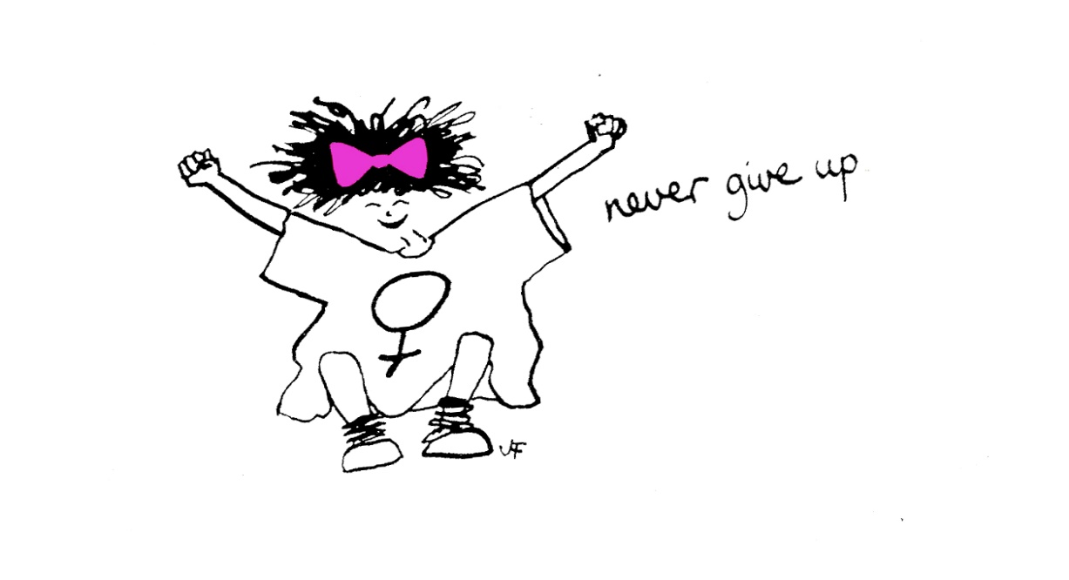
Evaluation of The Freedom Programme.
Spring 2019.

June 2019
Author: Sharon Bryan

Introduction
This evaluation examines the efficacy of The Freedom Programme. Through a quantitative assessment, this evaluation examines the impact and outcomes of the Freedom Programme for participants of the Spring 2019 programme.
Aim of The Freedom Programme.
The Freedom Programme is a support group designed for women who are, or have been experiencing domestic abuse. The Freedom Programme is designed as an intervention to empower women to make positive choices about their lives by providing information and support within a group setting. It gives women an opportunity and space to develop ways of thinking and behaving to protect themselves and their children from harm.
The aims of The Freedom Programme are:
- To help women understand the beliefs held by abusive men and in doing so, recognise which of these beliefs they have shared
- To illustrate the effects of domestic abuse on children
- To assist women to recognise potential future abusers
- To help women gain self-esteem and the confidence to improve the quality of their lives
- To introduce women to other women who share similar experiences
The Freedom Programme comprises 11, 90 minute sessions held weekly and run by a qualified facilitator. Resources and refreshments are provided for the women and whenever possible, childcare.
The Freedom Programme was developed in the UK by Pat Craven who works in the area of domestic abuse.
Evaluation Methodology
The information was collated using client questionnaires with qualitative and quantitative questions.
Process
- The client questionnaires were given out at the end of the 9th session.
- Participants were told there was no obligation to complete the forms.
- Participants were given the option of taking the questionnaire away and dropping it back to me at the office or completing there and then.
Response Rate
There were 10 women who attended 9 – 11 sessions. There were 2 women who attended only 4 sessions and who did not complete a feedback form. These women did not attend for reasons including being unwell, children being unwell, and having other appointments to attend. There was a 100% response from all 10 women who attended the programme consistently.
Main findings
The analysis was very positive. The main quantitative findings are outlined below.
- 100% of participants said The Freedom Programme had a positive impact on their lives/
- 100% of participants rated The Freedom Programme as helpful, of which 70% rated it as very helpful.
Because of their participation in The Freedom Programme:
- 100% agreed, of which 70% strongly agreed, the programme has resulted in a positive change in their lives
- 100% agreed, of which 50% strongly agreed, they are now more hopeful about the future
- 100% agreed, of which 50% strongly agreed, they were more assertive
- 70% agreed, of which 50% strongly agreed, they were more confident. 30% disagreed that they felt more confident, feeling they still had some way to go on their recovery before they would do.
- 100% agreed, of which 60% strongly agreed, they no longer blame themselves for their abuser’s behaviour
- 100% agreed, of which 80% strongly agreed, they can now make more sense of their abuser’s behaviour
- 90% agreed of which 70% strongly agreed, they now feel less alone in their experience of domestic abuse. 1 woman (10%), disagreed but could not define why.
- 100% agreed of which 70% strongly agreed, they benefitted from meeting other women on the programme
- 100% agreed of which 70% strongly agreed, they now expect to be respected
- 90% agreed, of which 60% strongly agreed, they can now recognise and identify abusive behaviour. 1 woman disagreed that she could identify and recognise abusive behaviour. She said it bore no reflection on the programme but was just how she was feeling at that moment.
- 100% agreed of which 50% strongly agreed, they feel they have the ability to respond to abusive behaviour
- 90% agreed of which 70% strongly agreed, they could now recognise an unhealthy relationship. The same woman who felt she could not identify and abusive relationship, also felt she would not recognise an unhealthy relationship. Again, she stated it was not a reflection on the programme but simply how she felt at the current time.
- 100% agreed of which 80% strongly agreed, that they understood more about the impact of Domestic Abuse on Children
As well as the quantitative findings, women had an opportunity to explain their reasons for selecting their answers. The main themes that emerged from the qualitative questions were:
- Greater strength and confidence – all the women felt their confidence had grown since attending the programme.
- More awareness of controlling behaviours towards them and signs of abuse.
- The peer bonding element of having group support was cited as being very important by all the women who attended the group programme. One of the women said meeting other women that had experienced domestic abuse was very helpful for her and she felt supported by them.
- More hope for the future – all the women felt that they had more hope for the future.
- Boundaries – all the woman felt they now had more awareness that the abuser was responsible for his own behaviour and no one else is.
- Rollout of the programme – many of the women commented that they hoped the programme would continue for other women. One woman suggested an extra session mat the end be added on ‘wellbeing’.

Detailed Analysis

Overall impact of The Freedom Programme
The overall impact was very positive with 100% of those who completed the questionnaire saying that The Freedom Programme had a positive impact on their lives.

What were the impacts of The Freedom Programme?

- “There are no words for how domestic violence changes a woman’s life. I am so grateful to the facilitators of this programme as I was given the support and closure I needed to move forward during a time in which I needed it most. It was the best thing to come out of this”.
- “It offered a space where I could learn more about domestic violence whilst supported by other women and knowing my child was receiving safe child care in the creche”.
- “That I’m not alone going through this. I know the difference between a good and bad relationship. I know the next relationship I’ll be in I’ll make a great choice and be respected and happy by my partner”.
- “It has made me so much more aware of abusive traits of the perpetrator. There were things I did not realise were forms of abuse, but, I do now!. It has opened my eyes”.
- “Very positive”.
- “I feel even more free. I know women are equal to men. Makes me realise how men try to control women and take advantage of ‘I’m the man’ and make us women feel worthless”.
- “It gave me confidence and strength. I am not afraid of anything now”.

Overall rating of the usefulness of the programme by participants
100% of course participants listed the programme as either helpful or very helpful.

Why?

- “It helped me understand what I was going through and equip me for the future. Meeting other women was very helpful and I felt supported. I am now fearless and strong”.
- “The Freedom Programme completely transformed me – I now have a greater understanding of domestic violence, the beliefs of the abuser and those I share with him. I feel very confident in identifying abusive behaviour and understanding the underlying beliefs of abusive men”.
- “By identifying traits of an abusive man, it helped me confirm and realise that behaviours shown by my child’s father were indeed abusive – in the past I may have excused some of them”.
- “Taught me a lot about ‘The Dominator’ and what is wrong”.
- “A really lovely, non-judgemental group. The facilitators are really amazing. They give examples, help us feel comfortable and the groups are always interactive/informative.
- “The Freedom Programme helped me a lot to change and improve myself”.
- “I think that every woman is free in Jesus Christ, but for women that do not know God, and her qualities, The Freedom Programme is very helpful, and it helped me even though I know I am free in Jesus”.

Which session did you find most useful?
Participants were asked which of the 11 sessions they found most useful and why.

- “I left each session eagerly waiting for the next one. I felt each session was crucial in showing the different faces of the abuser – how he could go from ‘The King of the Castle’ to ‘The Persuader’ – and helping me identify the different forms of abusive behaviour and the cycle of abuse”.
- “The session on the impact on children although every session has been insightful”.
- “The King of the Castle”.
- “All of the sessions were helpful for my future and my children’s. I can only say that every session is useful”.
- “All of them were”.
- “All the same as you learn about the different traits of the dominator each week”.
- “All the sessions”.
- “I cannot identify a particular one – they were all useful as they zoned in on different types of abuse”

Which session did you find least useful?
- “All sessions were equally useful for me”.
- “I’m not sure how I feel about the ‘labelling’ of men e.g. The Persuader, although in saying so, my partner definitely mirrored ‘the bully’!”.
- “The interactive session (rules of the game). I found this a little confusing”.
- “All sessions are useful”.
- “None!. I felt each was critical in helping us to identify the patterns of abusive behaviour and the underlying beliefs of the abuser. I now recognise how consistent his abuse was”.

Other suggestions/feedback
Participants were asked for any other comments or feedback.

“I hope other local authorities begin providing this programme, so other women may have the opportunity to attend”.
“This programme has had a resounding impact on my life. I am so grateful to have had the opportunity to attend”.
“I have no words to thank you enough”.
“I don’t think that without the Freedom Programme, I would be where I am now. The programme has changed my mine and my children’s lives. It has opened my mid to the ‘spell’ I was under”.
“The programme has made me see what has to change and the effects DV has had on my children. As a family we are now seeing councillors to address the effects it has had on me and the children”.
“It has given me the strength to stay away and given me the awareness to never go into another abusive relationship. It has made me feel empowered to be me without a man!”.
“The Freedom Programme had changed my life for the better. I think every woman who has or are going through domestic violence should do the programme”.
“Sharon has helped me change my life. I can relate to her very well and am happy I have had the chance to work with her”.
“Me personally, I think there should be more support from social workers and more refuges for women and children that live with domestic abuse and violence”.
“I would like more explanation of why abusive men are not angry?! Maybe this could be something added to the programme? As it is quite difficult to understand”.
“I did really enjoy being part of the group. I wish it could last for longer”.
“Thank you. I’ll miss going to the programme. After the sessions, I felt like a stronger woman leaving the building and more confident in who I am”.
“Some of the Freedom Programme videos that were shown at the ned of each session presented a picture-perfect version of happiness following leaving an abuser. However, I think it should be highlighted that this is not always the case”.

Conclusion

This evaluation of The Freedom Programme, is extremely positive. The programme had a deep resonance with participants and had very positive impacts on their lives. The group nature of the programme was key to its success, and friendships were formed amongst all of the women who had previously not known each other.

The location of the venue was important. There is a stigma around Children’s Services and a lot of women view Social Services as being against them. Therefore, I don’t believe they would have been able to relax if the programme were delivered from the Social Services building. Being away from that building gave the women permission to be more open and honest as they felt that they were making the choice to participate and that this was something they wanted to do away from the formal setting of an office – a place that reminded some of them of distressing situations they had experienced i.e. Child Protection Conferences etc. This programme was held in a Children’s Centre.

One of the things that always strikes me is how supportive all the women on group are to each other. Obviously, with the nature of the topic we were discussing, there was inevitably some women who became distressed whilst talking about their own experiences, and/or listening to other women’s accounts. There was no obligation for anyone to talk about their own situations and the programme is designed so that, that is not necessary. However, all the women choose to share their experiences with each other and supported each other accordingly.

The programme is, of course, serious, but there are also lots of opportunities for the women to laugh and have fun, especially when the programme content requires the women to talk in the voice of the abuser!

We had a tea break half way through each session where tea, coffee and biscuits are offered. The last session was a celebratory occasion and all the women brought in food to share and there was a celebration cake. The women were given their certificates of completion and attendance and each in turn spoke about what they will take away from the programme. Information was given on a programme starting in June called ‘Dare to Change’ which is held in the same venue as this programme by Hestia, which is another domestic abuse organisation in London. This programme is not specifically about domestic abuse but more about empowerment and building self-esteem and confidence. It is an appropriate follow on programme to The Freedom Programme for those women that feel they want to continue their journey of recovery. Six of the women asked to be referred to this programme.

The free creche facility was vital for the women who attended the programme. Most of the women did not have anyone else they could leave their children with and without child care, would not have been able to attend. Those women expressed also how it gave them some ‘me’ time, to be themselves and enjoy other women’s company without having to worry about their child. I plan to include a question on the feedback forms about the how important women feel free childcare is when accessing this programme. Childcare is costly, but in my opinion necessary if we want the programme to be successful.

The suggestions and feedback in this evaluation are very useful when planning any future programmes. It was heartening to see how all the women, some more than others, became more empowered during the programme.

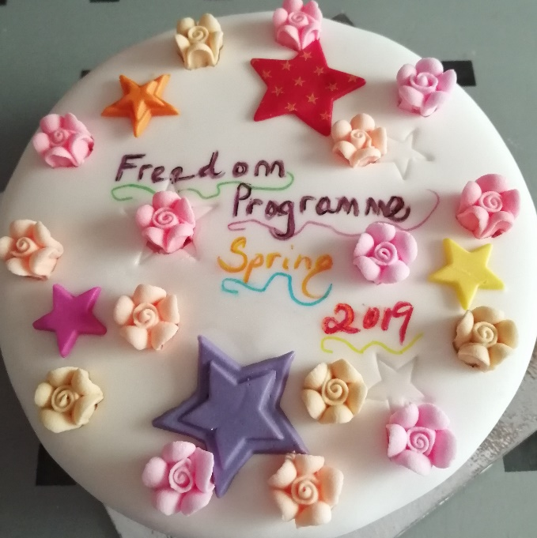

Sharon Bryan
Domestic Abuse Consultant
Early Help/Westminster Children’s Services
Spring 2019.

