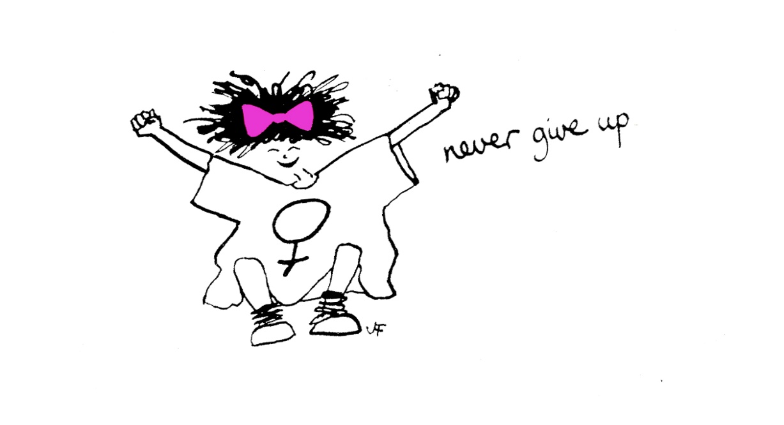
Evaluation of The Family Recovery
Freedom Programme – Spring 2016.

July 2016
Author: Sharon Bryan

Introduction
This evaluation examines the efficacy of The Freedom Programme which runs in Westminster for women who are involved with Children’s Services as a result of experiencing domestic abuse. Through a quantitative assessment, this evaluation examines the impact and outcomes of the Freedom Programme for participants of the Spring 2016 programme.
Aim of The Freedom Programme.
The Freedom Programme is a support group designed for women who are, or have been experiencing domestic abuse. The Freedom Programme is designed as an intervention to empower women to make positive choices about their lives by providing information and support within a group setting. It gives women an opportunity and space to develop ways of thinking and behaving to protect themselves and their children from harm.
The aims of The Freedom Programme are:
- To help women understand the beliefs held by abusive men and in doing so, recognise which of these beliefs they have shared
- To illustrate the effects of domestic abuse on children
- To assist women to recognise potential future abusers
- To help women gain self-esteem and the confidence to improve the quality of their lives
- To introduce women to other women who share similar experiences
The Freedom Programme comprises 11, 90 minute sessions held weekly and run by a qualified facilitator. Resources and refreshments are provided for the women and whenever possible, childcare.
The Freedom Programme was developed in the UK by Pat Craven who works in the area of domestic abuse.
The Domestic Abuse Consultant – Sharon Bryan, who works within Early Help recognised that there was a gap in service provision for women who wanted to feel empowered, whilst meeting other women who had experienced domestic abuse. Sharon Bryan undertook intensive training to become a qualified facilitator of The Freedom Programme in April 2014. as she felt this model best suited the service users she worked with.
From May 2014, the programme was piloted in the form of 1:1 facilitation by Sharon Bryan and the first group programme commenced in the Autumn of 2015. Sharon ran a second group programme in the spring of 2016.
There is a substantial amount of pre planning work that goes into running a group programme such as this one. There was no funding for a venue for this programme, so the sessions were held in a meeting room at Frampton Street. Childcare was also an issue. However, social workers were able to organise child minders for the women with preschool aged children so that they could attend.
Planning the sessions was vital so that the women were able to make full use of the time they had at each session. Each participant receives 2 books each – The Dominator and The Home Study Course Book. The Home Study book allows women to keep up with the sessions if they are unable to come to any of the sessions for any reason. These books are an important feature of the programme as they allow the women to look back at these in the future to see how far they have come. They are also able to evidence the work they have done to their children’s social workers and to Child Protection Chairs, where applicable. Formal letters were sent out to all participants ahead of the start date with information and directions to the venue, dates which the sessions would be held etc, so that the participants were fully informed of the commitment they were making and could plan ahead, which enabled maximum attendance.

Evaluation Methodology
The information was collated using client questionnaires with qualitative and quantitative questions.
Process
- The client questionnaires were given out at the second to last session for both the group programme and the 1:1 programmes.
- Participants were told there was no obligation to complete the forms.
- Participants were given the option of taking the questionnaire away and dropping it back to me at the office or completing there and then.
Response Rate
There were 9 women on the group programme, with between 6-9 women attending every session. There was 1 woman attending 1:1 sessions with myself. One of the group members had to go abroad unexpectedly and missed quite a few sessions. She is now completing the programme on a 1:1 basis with me and therefore has not completed a questionnaire yet. A total of 9 women were asked to complete the questionnaire. All 9 women were happy to complete, although 2 have not been received back yet.

Main findings
The analysis was very positive. The main quantitative findings are 100% positive, outlined below.
- 100% of participants said The Freedom Programme had a positive impact on their lives/
- 100% of participants rated The Freedom Programme as very helpful.
Because of their participation in The Freedom Programme:
- 100% strongly agreed the programme has resulted in a positive change in their lives
- 100% strongly agreed they are now more hopeful about the future
- 100% strongly agreed they were more assertive
- 100% agreed, of which 57% strongly agreed, they were more confident
- 100% agreed, of which 57% strongly agreed, they no longer blame themselves for their abuser’s behaviour
- 100% strongly agreed they can now make more sense of their abuser’s behaviour
- 100% agreed of which 85% strongly agreed, they now feel less alone in their experience of domestic abuse
- 100% agreed of which 80% strongly agreed, they benefitted from meeting other women on the programme – this is based on the women who attended group. There were 2 women this was not applicable to as they did the programme 1:1
- 100% agreed of which 85% strongly agreed, they now expect to be respected
- 100% strongly agreed that they are now more aware about domestic abuse and its effects
- 100% strongly agreed they can now recognise and identify abusive behaviour
- 100% agreed of which 57% strongly agreed, they feel they have the ability to respond to abusive behaviour
- 100% agreed of which 71% strongly agreed, they could now recognise an unhealthy relationship
- 100% agreed of which 85% strongly agreed, that they understood more about the impact of Domestic Abuse on Children
As well as the quantitative findings, women had an opportunity to explain their reasons for selecting their answers. The main themes that emerged from the qualitative questions were:
- Greater strength and confidence – all the women felt their confidence had grown since attending the programme
- More awareness of controlling behaviours towards them and signs of abuse – one woman said she had been seeing a man for a few weeks and had now ended their relationship because she recognised some of his behaviour as potentially abusive
- The peer bonding element of having group support was cited as being very important by all the women who attended the group programme. One of the women said she no longer felt that she was the only woman that had experienced abuse. Another woman said she realised that she had been far too judgemental of women before i.e. she recognised one of the other participants from her son’s school and said that she never would have thought before, that they had anything in common and had judged the woman by the way she looked. She realised she had been wrong to stereotype the woman in the way she had.
- More hope for the future – all the women felt that there was now a ‘light at the end of the tunnel’ for them.
- Boundaries – all the woman felt they now had more awareness that the abuser was responsible for his own behaviour and no one else is.
- Rollout of the programme – many of the women commented that they hoped the programme would continue for other women and suggested that it also be rolled out to professionals so that they would be much more aware of what women went through.

Detailed Analysis

Overall impact of The Freedom Programme
The overall impact was very positive with 100% of those who completed the questionnaire saying that The Freedom Programme had a positive impact on their lives.

What were the impacts of The Freedom Programme?
- “It was a massive transformation. It helped me to turn my way of thinking”
- “The negative way of thinking that my husband had, made me the way I am. Now I think positively”.
- “I am stronger, happier and it has boosted my confidence”.
- “I learned to recognise the warning signs and tactics of an abuser”.
- “An important aspect for me was to stop blaming myself for getting involved in abusive games with my ex”.
- “I loved the programme. It has helped me to see things more clearly. I am able to identify abusive behaviour and I don’t think the chances are very high that I will end up in another relationship with an abusive man”.
- “The handbooks were very good at breaking down the reality of Domestic Abuse. Also the role of the abuser really hit home”.
- “I have learnt a lot about myself and the abuse that I have been through and to understand and recognise signs of domestic abuse and how to prevent it”.

Overall rating of the usefulness of the programme by participants
100% of course participants listed the programme as useful.

Why?
- “For all the reasons I gave about the impacts”.
- “I constantly have in mind all of the ‘trigger’ traits of an abusive, controlling man”.
- “I feel that having completed The Freedom Programme, my knowledge of Domestic Abuse will always remain with me”.
- “I can identify abusive behaviour in a way I previously couldn’t”.
- “It has made me look at, question and be aware of my own beliefs”.
- “It has made me grow as a person”.
- “I believe the information I learnt will help me to make healthier choices in relationships in the future”.
- “Because it gives me huge courage to carry on with day to day life”.
- “It helps me cope with the traumatic experiences I have had”.

Outcomes of The Freedom Programme
The Women who participated in The Freedom Programme were asked to rate how they agreed with the following statements after taking part in The Freedom Programme. The results were overwhelmingly positive.

Which session did you find most useful?
Participants were asked which of the 12 sessions they found most useful and why.
- “The Liar. I liked the ‘Rules of the Game’ video as it illustrated the many different ways men can be abusive”.
- “The Liar. This session helped me to recognise abusive behaviour and I also learnt from the other women’s experiences”.
- “The warning signs. It helped me to learn about what to look out for in the future”.
- “They were all helpful”.
- “All the sessions were a positive learning experience and I have learnt a lot from all the sessions in detail”.
- “All of them. It has changed my life”.
- “I cannot choose one session because all of the sessions were all so useful”.
- “King of the Castle, because it was very relevant to my situation and helped me realise how domestic abuse was rooted in attitudes. I found all questions about my own attitudes helpful as I realised that I held some beliefs myself from my own upbringing which did not help me”.
- “The Liar. I really liked the role play as it made it seem real but was also quite funny!”.
- “I found the parts of the sessions where we had to respond to situations as if we were the abuser, really helpful and it made us all laugh”.

Which session did you find least useful?
- “I found all sessions useful”.
- “The Sexual Controller as this was not an issue in my case”.
- “I haven’t got one that wasn’t useful. They all were”.
- “They were all good. I learnt a lot from all of them”.
- “I thought they were all useful in different ways to different women”.

Other suggestions/feedback
Participants were asked for any other comments or feedback.

“The Freedom Programme is a fantastic programme to be on. The co-ordinator of the sessions, Sharon Bryan, has been brilliant in supporting us women on the group and always had our sessions planned so that we could make the most of our time”.
“All of the women on the group were very open and honest about their experiences which made me feel not alone in my situation”.
“I would recommend other women who experience DV to attend this group. Thank you Sharon Bryan ”.
“I think it would have been nice if my husband could have come and joined in a session to share the experience with me. He is doing DVIP and reads my Freedom Programme book and together the programmes have changed our lives and our relationship for the better”.
“I didn’t like the part in the book that said that men that attend The Freedom Programme change their behaviour. My understanding is that most abusive men actually don’t change and I think this remark will give women false hope that their partners will change. In the book, it sounds like it is normal but I don’t think so. I think change of behaviour is more the exception. I have asked Sharon Bryan to feed this back to the creator of The Freedom Programme which she did do and showed me the response from Pat Craven which helped me to understand in what context It is crucial, she talks in the book. It was also really good of her to take the time to respond”.
“Maybe, it would be helpful to be more specific about how to respond to more examples of abuse. For example, my ex used to blame me and call me selfish for wanting to have time for myself. I would like to know about specific ways to respond to this kind of thing”.
“I don’t think each chapter necessarily needs equal weight on a one to one course as some character traits may not be relevant in certain situations. I think it would be good material for a group because people would hear other women talking about elements of the dominator and recognise their own experience, but I did the programme one to one with Sharon Bryan, so we could have concentrated more on the relevant sessions for me”.
“The Freedom Programme is very good for helpless women like me. Or that is how I felt. I very much appreciated the intervention and highly recommend for other women, especially with children. It is crucial, when domestic abuse starts, to intervene straight away, otherwise in the end you just feel it is normal. This is based on my experience of 9 long years and it has been a nightmare”.
“The chance to share my experiences with other women who just knew exactly how I felt was lifesaving. I’m so glad I did the programme. I gained so much knowledge”.
“I loved the programme. I didn’t want it to end!”.

Conclusion
This evaluation of The Freedom Programme, was extremely positive. The programme had a deep resonance with participants and had very positive impacts on their lives. The participants enjoyed both the sessions and also the time spent with other women in similar experiences. The group nature of the programme was key to its success, but it should also be noted that the women who completed the programme on a 1:1 basis with myself, also felt that the programme had had a positive impact on their lives.

One of the things that really struck me was how supportive all the women on group were to each other. Obviously, with the nature of the topic we were discussing, there was inevitably some women who became distressed whilst talking about their own experiences. There was no obligation for anyone to talk about their own situations and the programme is designed so that, that is not necessary. However, all the women choose to share their experiences with each other and supported each other accordingly.

The programme is, of course, serious, but there is also lots of opportunities for the women to laugh and have fun, especially when the programme content requires the women to talk in the voice of the abuser!

We had a tea break at each session and the women would bring in biscuits and doughnuts to share, which they didn’t need to do, but wanted to. The last session was a celebratory occasion and all the women brought in food to share. The women were given their certificates of completion and attendance and those that wanted to, swapped telephone numbers so they could stay in touch.

The suggestions and feedback in this evaluation are very useful when planning future programmes. The resounding suggestion is to extend the programme so that other women who are or have experienced domestic abuse can benefit from the programme, as well as delivering it to professional practitioners working in the area of domestic abuse.

Sharon Bryan
Senior Domestic Abuse Consultant
Family Recovery Programme
City of Westminster Council
July 2016.

